**Exploring the Power Query Editor interface**

-> In Power Query Editor ensure that Query Settings be there all the time if for some reason it is not their go to view --> click on Query settings.

-> In left pane (Queries) can be collapsible click on <.

-> In Power Query Editor to hide or unhide formula bar go to view --> uncheck Formula Bar.

---------------------------------------------------

**Introducing the M language**

-> Here Navigate through Applied settings and observe in formula bar for each step we have a different formula.

-> These formula are written in M language.

-> google power BI M language.

-> Select URL: https://learn.microsoft.com/en-us/powerquery-m/

-> Select functions tile and analyse URL: https://learn.microsoft.com/en-us/powerquery-m/power-query-m-function-reference

-> It is near impossible to memorize these function so, click on download PDF and save it.

-> PPT Highlight the most important function that we use in the class discussions and most useful for certifications.

-> One thing to be kept in mind is that most of the options available in "Transform and ADD Column" are transformed into M language.

-------------------------------------------------

**Let's start look at the Home tab**

1. Close apply 2. New Sources 3. Recent Sources 4. Enter Data. (By this Time you know all these options)

5. Manage (Drop Down)--> Delete, Duplicate, Reference.

-> Duplicating a query copies the current query.

-> Referencing a query only copies the location of its data source.

6. Refresh Preview: To refresh the data source for new data if any added.

7. Properties: to name and add description to your file.

8. Advanced Editor: Used to create M code (will see in detail later classes)

9. Manage Parameters and Data Source Settings (Used to put UN/PW for data bases) we see later.

---------------------------------------------------

**Home menu - Manage Columns**

-> Manage Columns and Reduce Rows are used to reduce Columns and Rows.

-> Click Choose Column (Drop Down) --> Go to Column --> used to go to a particular column (Does not apply any additional steps).

-> If we want to highlight multiple successive column "select first column + shift and last column".

-> If we want to highlight multiple discreate columns ""press and hold CLT + t columns of interest".

Note: All of these operation Does not add any additional steps into the applied steps. Any steps will be add if and only if any changes are made.

->Click Choose Column (Drop Down) --> Choose Column --> uncheck all columns and select first two column and observe in applied steps.

-> A step will be added named " Removed Others Columns" observe the formula in formula bar.

= Table.SelectColumns(#"Changed Type",{"Catalogue of V:\Music\Album", "Column2"})

-> Previous step (Changed Type) is updated with selected columns list.

-> You can rename your applied step to any name.

-> Now delete the Removed Others Columns.

-> Remove Columns: Remove selected or unselected columns.

-> You can rearrange/reorder the column to any order by drag and drop to a position or rewriting the formula with column place holders.

-> Some of M Functions used are: Table.ReorderColumns, Table.SelectColumns, Table.RemoveColumns.

-----------------------------------------------

**Home menu - Reduce Rows and Use First Row as Headers**

-> analyse the original excel data steep for CD.

-> Now delete the step reordered columns, ChangeTypes and Promoted Headers.

-> Now we are in Navigation step where data view is same as source file.

-> Now we want to make 4th row as column header to make sense.

-> now in Reduce Rows pane --> keep Rows option --> explore all options and analyse what will happen to your data view and delete once operation is complete in applied steps one after another. (In each case observe the formula and function calls)

-> now in Reduce Rows pane --> Remove Rows option --> explore all options and analyse what will happen to your data view and delete once operation is complete in applied steps one after another. (In each case observe the formula and function calls)

Come to Use case for removing and making the first row as header.

-> Now in Reduce Rows pane --> Remove Rows option --> select first 3 rows. (Also observe the new step applied and formula we got a new formula)

-> Select Use first Rows as Headers and analyse the formula. A new step will be added. (Changed type) and

-> Close and Apply

-> In Report View we see all transformed fields can be seen.

-> In Data accessed , created and modified - data hierarchy is add as Power BI recognized it as Date data type.

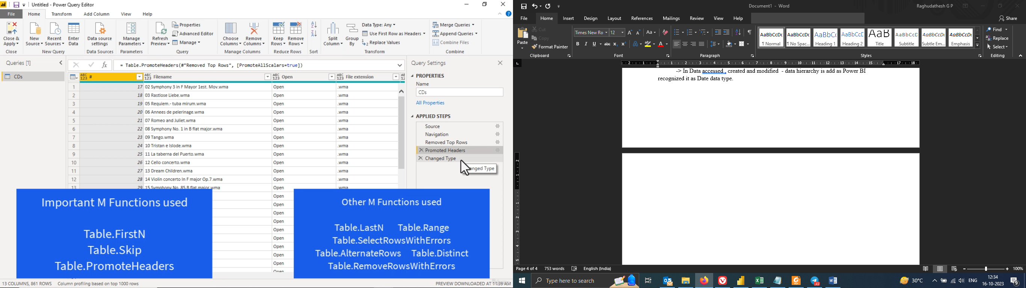

**Sort and Filter**

Sorting

* Go to power query editor
* Now say we want to sort the number column ascending or descending we can do this by using sort ascending or descending option when we do so a new applied steps is added as “ Sorted Rows”.

= Table.Sort(#"Changed Type",{{"#", Order.Ascending}})

* Now do the opposite of above step say sort by descending then new applied step is not added but get modified in the current query (Table.Sort).
* Remove the Sorted Rows Steps.

Filtering:

Usecase: Say I don’t want now a file format “.wma” then

* Select the file extension column and uncheck the file format, a new step called filtered Rows get added and examine the formula.

= Table.SelectRows(#"Changed Type", each ([File extension] <> ".wma"))

* Now say do a sorting descending and new step is added, now go back and check the file extension we lost the .wma options, we move beyond that. Now, analyse how is handled in M language:

= Table.Sort(#"Filtered Rows",{{"#", Order.Descending}})

* Same way check the formula for Filtered Rows:

= Table.SelectRows(#"Changed Type", each ([File extension] <> ".wma"))

* If require you can change the file extension is, formula manupulation.
* Now delete Sorted and Filtered steps and in “change Type” step try filter option -> number filter -> explore between option and analyse the formula also.

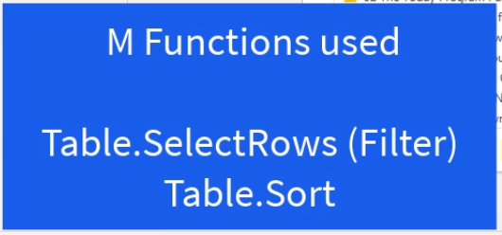

**Split Column**

Now make the “Folder path column” as last column. We need to split into multiple column use Split Option.

Split Column 🡪 Delimiter. This help to analyse the data by album type.



**Other Transform activities**

**Group BY: To analyse the data based on some condition.**

**Select Group By🡪 File extension 🡪 size this will show you the data wrt size vs file type for entire data set.**

**Check all the aggregation sum, avg, all rows etc.)**

**Data Type: Used to check the type of data like decimal number, whole number, date/time etc.**